**Modeling phase**

Random forest regressor model:

is a Supervised Learning algorithm which uses ensemble learning method for classification and regression.

The trees in random forests are run in parallel. There is no interaction between these trees while building the trees.

**The results of the model on the dataset which preprocessed with one hot encoding technique:**

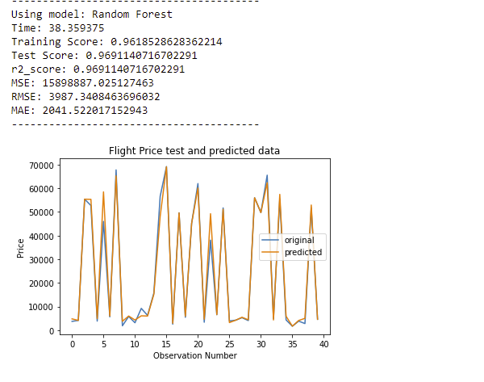

**The results of the model on the dataset which preprocessed with target encoding technique:**

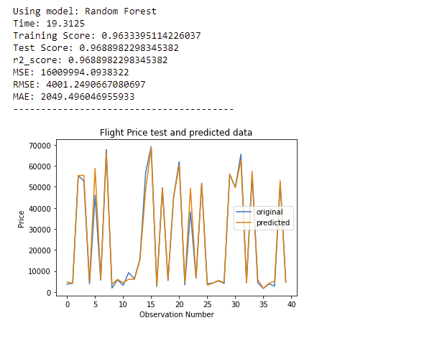

**The results of the model on the dataset which preprocessed with one Frequency domain encoding technique:**

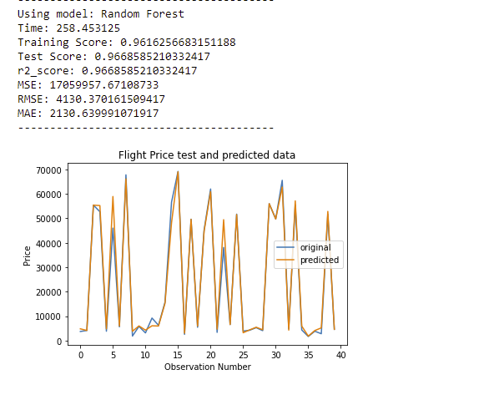

**Bagging regressor Model:**

is an ensemble meta-estimator that fits base regressors each on random subsets of the original dataset and then aggregate their individual predictions (either by voting or by averaging) to form a final prediction.

**The results of the model on the dataset which preprocessed with one hot encoding technique:**

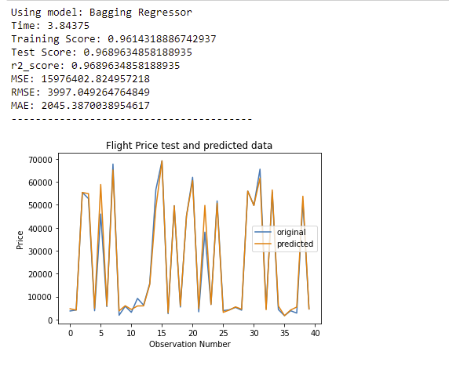

**The results of the model on the dataset which preprocessed with target encoding technique:**

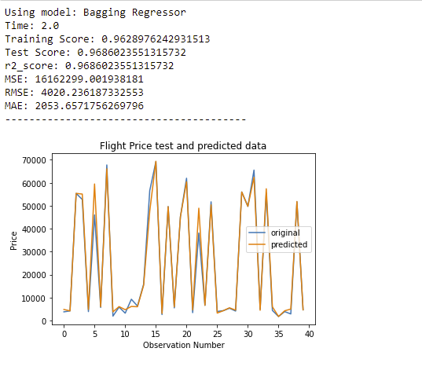

**The results of the model on the dataset which preprocessed with one Frequency domain encoding technique:**

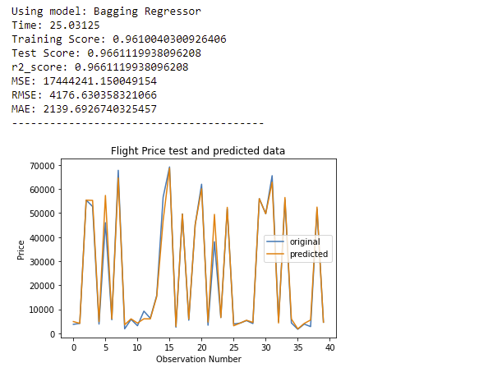

**Decision tree regressor Model:**

Decision tree builds regression or classification models in the form of a tree structure. It breaks down a dataset into smaller and smaller subsets while at the same time an associated decision tree is incrementally developed. The final result is a tree with decision nodes and leaf nodes.

**The results of the model on the dataset which preprocessed with one hot encoding technique:**

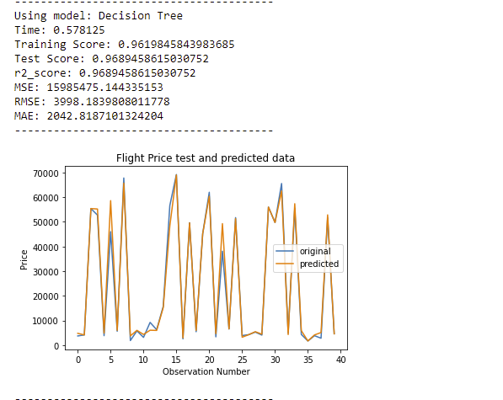

**The results of the model on the dataset which preprocessed with target encoding technique:**

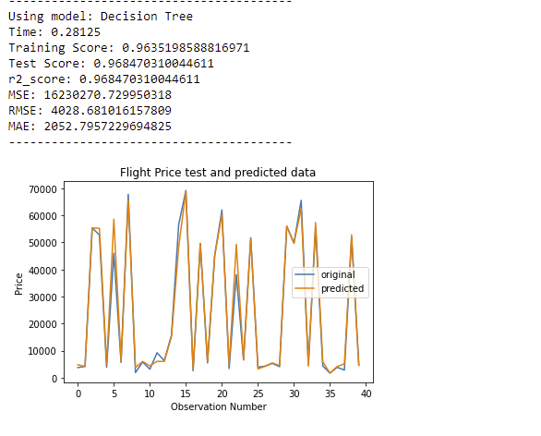

**The results of the model on the dataset which preprocessed with one Frequency domain encoding technique:**

